Chapter 15, Solution 41.

We fold x(t) and slide on y(t). For t<0, no overlapping as shown below. x(t) =0.

y()

4

0 2 4 6 8
t

-4

For 0 < t < 2, there is overlapping, as shown below.

y()

4

0 t 2 4 6 8

-4

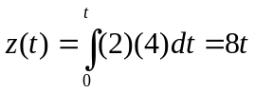
For 2 < t < 6, the two functions overlap, as shown below.

y()

4

0 2 t 4 6 8
t

-4

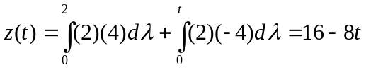

For 6<t<8, they overlap as shown below.

y()

4

0 2 4 6 t 8

-4

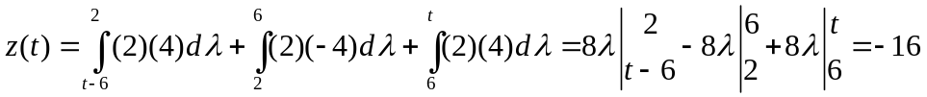

For 8< t <12, they overlap as shown below.

y()

4

0 2 4 6 8 10 t 12

-4

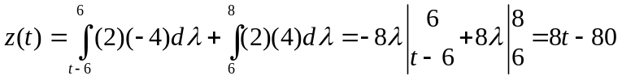

For 12 < t < 14, they overlap as shown below.

y()

4

0 2 4 6 8 10 12 t

-4

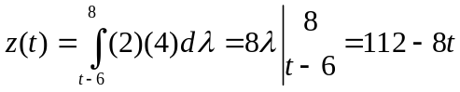

Hence,
z(t) = 8t, 0<t<2
16–8t, 2<t<6
–16, 6<t<8
8t–80, 8<t<12
112–8t, 12<t<14
0, otherwise.

